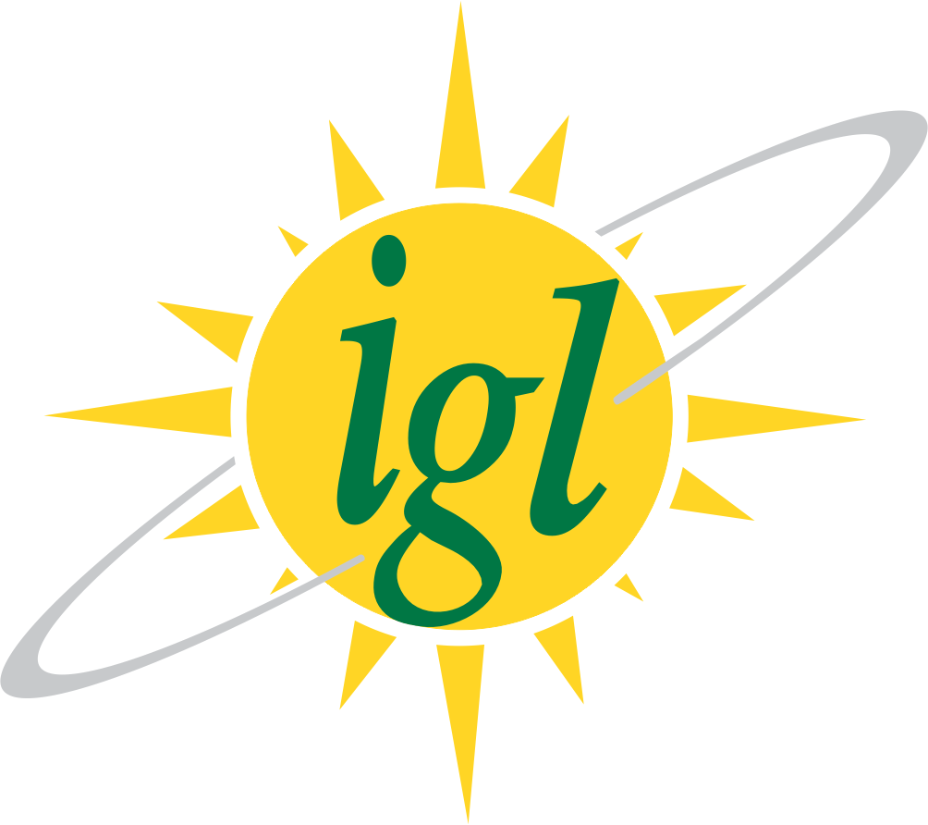 Dated: 06.11.2024

**New Notice for Inviting Expression of Interest (EOI) under Company Owned Company Operated (COCO) and Dealer Owned Dealer Operated (DODO) Models for CNG Stations.**

**Due Date for submission of online application is now extended till 20th November 2024.**